Edbo Genet

The Evolution of Skateboarding

As Ben Marcus points out in *The Skateboard: The Good the Rad, and the Gnarly,* skateboarding was born out of the California surfing boom of the late forties and early fifties. (Marcus, 248)(Slee) Just as skateboarding was born out of the early California surf scene, my interest in skateboarding was wetted by surfing the coast of North Carolina. Unlike the smooth transition one can make from surfing to skateboarding (because the movements are fundamentally very similar), the beginnings of skateboarding were pretty rocky. Early skateboards were very different, and lacked almost all of the features that are available with the factory produced boards of today. Early skateboarders were forced to create their own boards with plywood and roller skates, and many of these creations were very crude and undoubtedly provided anything but a ‘smooth’ ride.

This essay will analyze the development of Skateboarding from its humble roots as a pastime for surfers on waveless days. There will be a great deal of YouTube videos in this essay, since “Skateboarding is a field in which visual representation (in the form of photography and video) has been a significant long-running concern.” (Buckingham) In analyzing the development of the sport of skateboarding, this essay will first look at the technological advances that have occurred with skateboards and the ways that skaters have progressed the sport. In the end, this paper will take a look at the current themes in skateboarding.

The early roots of skateboarding are pristinely encapsulated in a quote from Mike Doyle, who was a pioneer in both the surf and skate scenes of 1950s California. Doyle writes about the metal wheels that the first skateboards were equipped with, he wrote that “the streets were too rough for the metal wheels, so we had to stick to the sidewalk: downhill runs, and the thrill was trying to make the corner without slipping out and having to bail out.” (Marcus, 299) Although going fast and trying not to wreck ones “shit” is still a large part of the appeal of skateboarding, the technology that was available to Doyle in the 50s was incredibly rudimentary.

One thing that this early skating can teach us about is the athleticism that has always been a part of Skateboarding. Going fast, riding down big hills on one of these surely required a great deal of athletic ability, and guts.

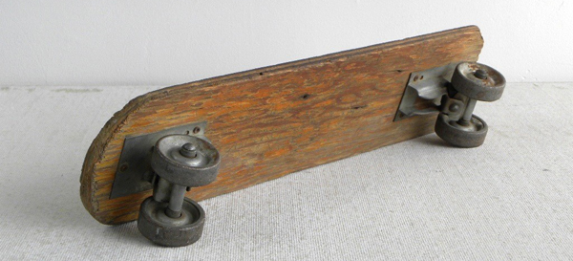

Metal wheels of the early skateboard movement, and the clay wheels that arose shortly afterward, did not offer much room for improvement on the part of riders. Hard wheels make skating on any surface that is not flat very difficult. Keeping momentum with all of that resistance is near impossible. As you can see from this YouTube clip, there were not many stylistic options on these early skateboards (<https://www.youtube.com/watch?v=W20Atp9fuJI>). Just like the early 100lb hardwood surfboards, early skateboards had very limited maneuverability, and maneuverability is a quintessential aspect of any board sport. Skaters were only able to rip left and right, turn stylistically, or do head stands. However, as you can see in the picture below, 50s skateboarders definitely took advantage of the technologies that were available, and they were able to squeeze a lot of style out of those clay wheels.

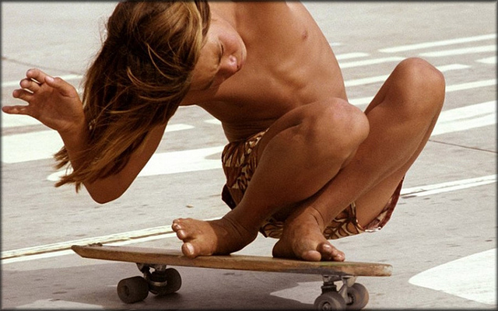

Skateboarding skyrocketed in popularity in the early sixties. American children were enthralled by the sport in the movie *Gidget*, which featured skateboard scenes, and for the first time commercially made skateboards were available, no longer did skaters have to MacGyver their boards our of plywood and rusty roller skates. (Marcus, 276) This boom saw the rise of Skateboarding in popular culture, kids books of the day featured skateboarders. (Marcus, 276) Skateboarding’s success in the early sixties did not last though, the sport’s popularity abruptly crashed in the middle of the decade (SkateMag).

Metal and clay wheels did not allow for much room to excel in the sport, and the skill cap plateaued. Because there was no room to advance ones skill, people flocked away from the sport. The dangerous nature of the clay and metal wheels may also have contributed to the decline in popularity.(SkateMag) Just as with any hard wheel, the clay and metal skate wheels had a tendency to lock up when encountering a foreign object on the street, causing the rider to get thrown forward. The hard wheels were also very slippery at high speeds, so riders would often have little control at high speeds, which is also dangerous.

However, “the invention of urethane wheels by Frank Nasworthy in 1972 made it possible for skateboarding to make its comeback.” (SkateMag) With urethane wheels, skateboards were no longer so difficult to ride. The softer petroleum based wheels made riding on any surface easier and faster, they provided a smoother ride on rough roads, they afforded greater turning control everywhere, and they made it easier to ride vertical surfaces on account of their significant increase in gripping power.

After the invention of the urethane wheel, skateboarding was conquered by one group of skateboarders from Venice Beach, California. The Z-boys were a motley group of young teenagers who, once they realized the potential of the urethane wheel, took the sport to a new level that had not been realized before. (SkateMag) Staci Peralta, Tony Alva, and Jay Adams were all original members of the Z-boys group, and they have gone down in history as the disciples of modern skateboarding.

This video illustrates the new capabilities that urethane wheels gave to the world of skateboarding, and the Z-boys in particular (<https://www.youtube.com/watch?v=L00yro9NvsQ>). The first visible benefit from the new wheels was the speed. In the video you can see a young Jay Adams flying down a hill, his arms stretched in front of him, and his back foot pivoted on its side, he is surely going faster than anyone ever could on a skateboard with metal or clay wheels while still maintaining any facet of control over their board. The friction generated by the harder wheels would not allow a rider to reach such speeds and still maintain control over the boards direction.

Another benefit of urethane wheels that is depicted in the video is the ability to ride walls. The Z-boys, of Zephyr team, became famous for their dedication to and proficiency with skating swimming pools (illegally). As is depicted in the video above, the members of the team would clean empty pools, and even empty them of water, so that they could ride their boards into the deep end and up the walls towards the coping on the top of the bowl. Riding on vertical surfaces in such a fashion was an entirely new arena of skateboarding. Now a regular feature at skate parks: the pool, or bowl, offers excellent opportunity to showcase the abilities of urethane wheels.

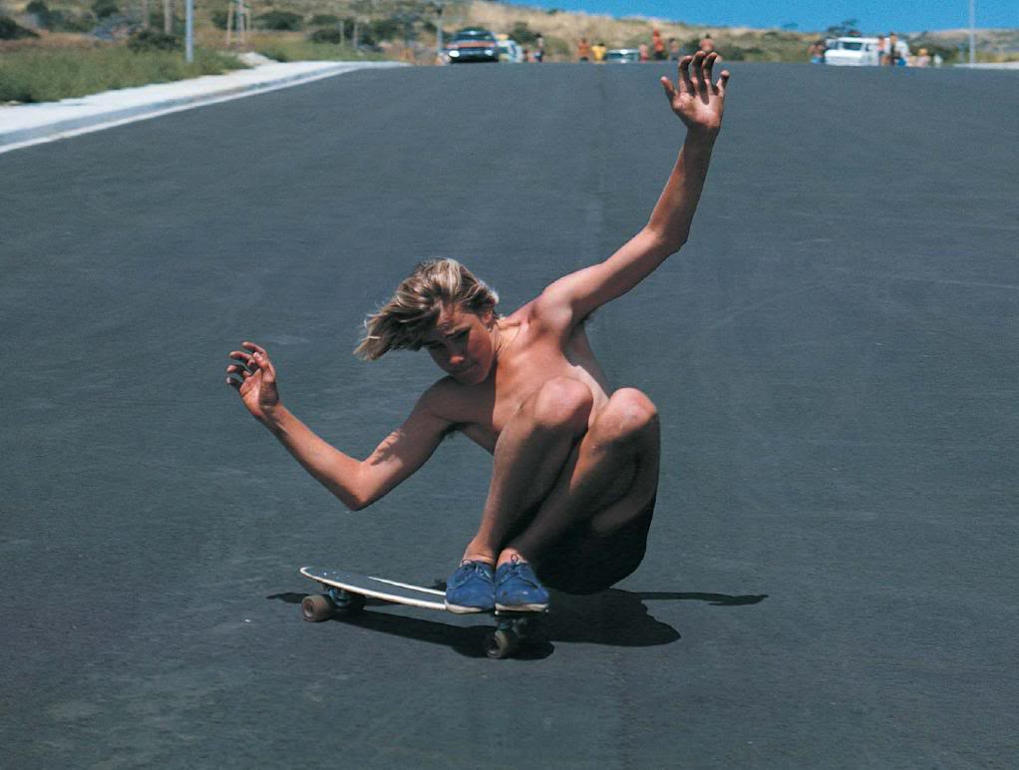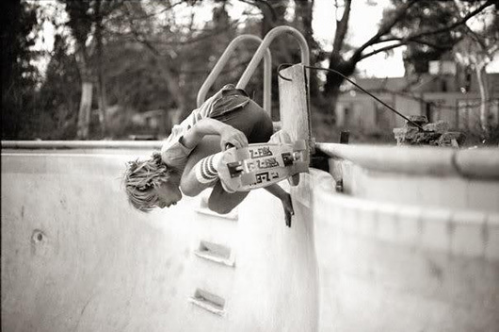

Jay Adams, who is pictured above, and his teammates the Z-boys certainly progressed the sport of skateboarding. The Zephyr Team’s willingness to illegally break into people’s backyard pools and go fast, ride on vertical surfaces, and to maneuver while staying low at high speeds, introduced new styles of riding to the sport. Their contribution to the skating world led to a resurgence in the popularity of the sport. (SkateMag) Enthralled by the Z-boys, and their wildly progressive abilities, young people started picking up skateboards again in the mid seventies.

There were other faces that made contributions to the Skateboard world in the seventies besides the Z-boys. In 1978 skater who went by the nickname “Ollie” invented the move that is now referred to by his name.(SkateMag) Ollie pioneered the move in which a skateboarder pushes down on the back of their board, and up and forward on the front of their board, in order to bring their feet, and their board off of the ground. This move is now one of the primary building blocks of Skateboarding, the move “completely revolutionized skateboarding.” (SkateMag)

The 1980’s is when skateboarding really started to morph into what it is today. During the 80’s skateboard design started to become customized to those who wanted to pop Ollies and to technical footwork. On top of turning fast, riding walls, and sliding around, riders in the 80’s started to use their areal and foot skills in ways not possible with earlier, heavier and less maneuverable boards. This early video of Rodney Mullen is a great example of this early footwork (<https://www.youtube.com/watch?v=SNzBkpxmEvw>).

The Bones Brigade, a collection of young skaters in the 80s, was a lot like the Zephyr Team, except way less motley. The Bones Brigade was started, and funded by one of the original Zephyr team members, Stacy Peralta. And many of Skateboarding’s most famous names were part of the Bones Brigade, including Tony Hawk, Rodney Mullen, Bucky Lasek, and Tommy Guerrero.

Just as the Zephyr Team pushed the limits of their equipment and opened new arenas in the world of skateboarding, the Bones Brigade pushed the envelope throughout the 80s. The boards that the Bones Brigade were essentially the same as the boards that are used today. The boards feature the same ureuthane wheels that the Z-boys used, but the trucks the Brigade had were much lighter, and their boards were shaped with a convex surface to facilitate areal control.

In this YouTube video, the Bones Brigade members are routinely practicing the fundamentals laid down by the Z-boys, their slides, coping rides, and bowl riding are all reminiscent of the 70’s era skating (https://www.youtube.com/watch?v=5X9iROyjYnU). However, they are also practicing new moves that they themselves were pioneering. All of the secondary footwork like the kickflip was created by this gang of young skateboarders. They also pioneered street skating, which is when skaters haul down streets maneuvering around, on top of, and into public features in stylistic, technical ways (these can be grinds, jumps, or any other fashion of riding) The Bones Brigade released a slew of skate videos, and the only difference in their skating in the mid 80’s and the style of skating now is the modern lack of neon headbands and knee pads. Skateboarding has, since the 80’s, almost been frozen in a state of technological purgatory.

Skateboards just have not changed much since the late 80s. This has caused the sport to appear less exciting to some who view this technological stableness as boring. However, just as the Z-boys and the Bones Brigade progressed the sport of skateboarding, there are skaters now who are pushing the envelope. Now though, it appears as though “pushing the envelope” in skateboarding can only be done in two ways. First, a skater can embark upon a maneuver that is physically impressive, such as Ryan Sheckler’s famous kickflip over the “Costco Gap” (this video is a must watch) (<https://www.youtube.com/watch?v=OeZ3oRHEukU>). The second outlet for skateboarders who want to push the envelope is the culture of skateboarding itself. The image of the Skateboarder as degenerates is a pretty popular one, “Skateboarders are often seen as outsiders.” (Moore) AS this video of Deer Man of the Darkwoods shows, some great skaters of today push the envelope not only by being great athletes, but also by embracing the “degenerate” image (https://www.youtube.com/watch?v=dWAQMUe1veQ).

Works Cited

Marcus, Ben, and Lucia Daniella. Griggi. *The Skateboard: The Good, the Rad, and the Gnarly: An Illustrated History*. Minneapolis, MN: MVP, 2011. Print.

<http://www.skateboardingmagazine.com/the-evolution-of-skateboarding-a-history-from-sidewalk-surfing-to-superstardom/>

<http://thesportjournal.org/article/an-ethnographic-study-of-the-skateboarding-culture/>

<http://scholarcommons.usf.edu/cgi/viewcontent.cgi?article=1032&context=honors_et>

<http://www.academia.edu/679738/Skate_perception_self-representation_identity_and_visual_style_in_a_youth_subculture>

Image

http://www.skateboardingmagazine.com/top-5-innovations-in-skateboarding-history/

<http://www.google.com/imgres?imgurl=https://skateboardology.files.wordpress.com/2014/11/skating-50s.jpg&imgrefurl=https://skateboardology.wordpress.com/tag/history/&h=400&w=640&tbnid=MN29wLImSWZ3XM:&zoom=1&docid=OTCKEx8g_4RShM&ei=PP9LVbCcB4n1oATbxIBw&tbm=isch&ved=0CJEBEDMoYTBh>

<http://www.google.com/imgres?imgurl=http://nonprofitofflorida.org/wp-content/uploads/2015/01/pic13-jay-adams.jpg&imgrefurl=http://nonprofitofflorida.org/the-icon-jay-adams-receives-the-2015-legend-award/&h=772&w=1022&tbnid=d4LGlnovq29hVM:&zoom=1&docid=Izxo2TdqYS8coM&ei=YgBMVffDDYStogTxs4CICw&tbm=isch&ved=0CGgQMygsMCw>

http://www.osirisshoes.com/media/media/team-member/jay-adams-fruitbowl-75.jpg